Hands – On Lab Workshop 1

# Survey Form

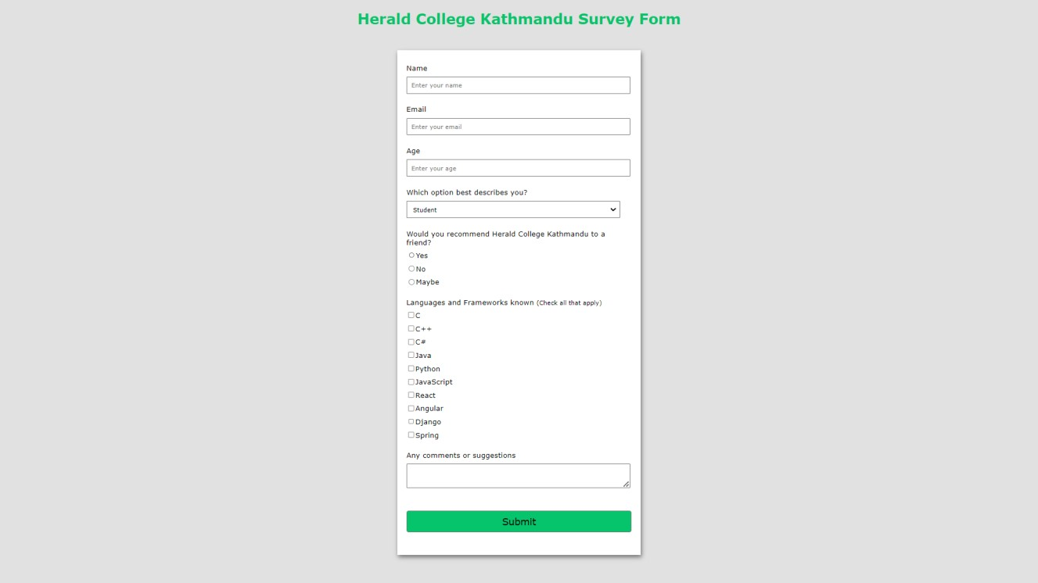Using HTML and CSS (inline and internal) only, create a survey form as in the given figure:

GitHub Link:

<https://github.com/banid8/Internet-Software-Architecture/tree/main/Week%201/Survey>

# Creating a Simple Web Page

Create a simple web page which must include the following sections:

1. Logo
2. Navigation Menu (Home, About, Service, Contact)
3. Search Box and icon
4. Heading Text
5. Use of <p> and <span> tag with different styling
6. Button
7. Form
8. Social media icons
9. Footer section
10. Background image

GitHub Link:

<https://github.com/banid8/Internet-Software-Architecture/tree/main/Week%201/Kathmandu>

# XAMPP Control Panel

Download and install Xampp Server on your computer and run the web page build in question 1 and 2 using localhost. See the difference between running a page with localhost and directly.

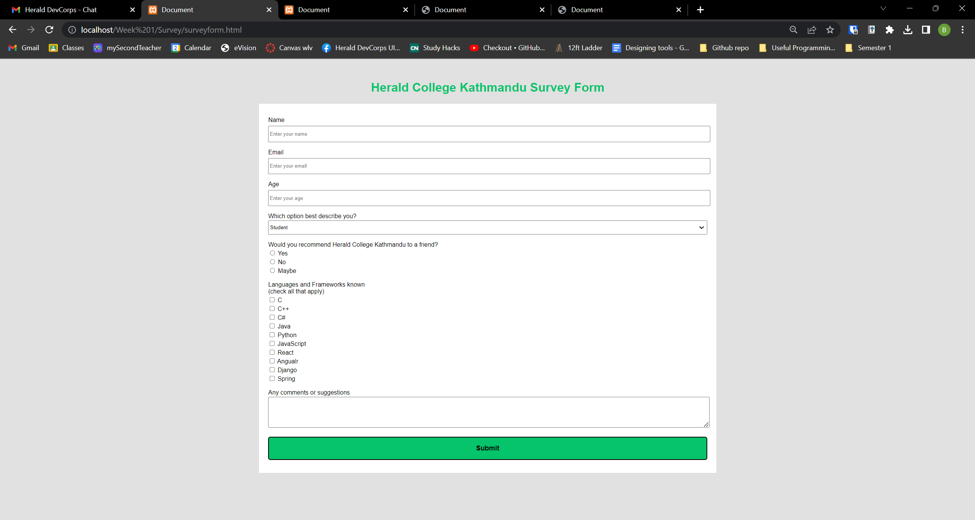



# Web Performance Visualization

For the created web pages, visualize the web performance using devtools, following the steps:

1. After running the file in the browser, right click on mouse and go to inspect
2. Check the network and performance options for the visualization

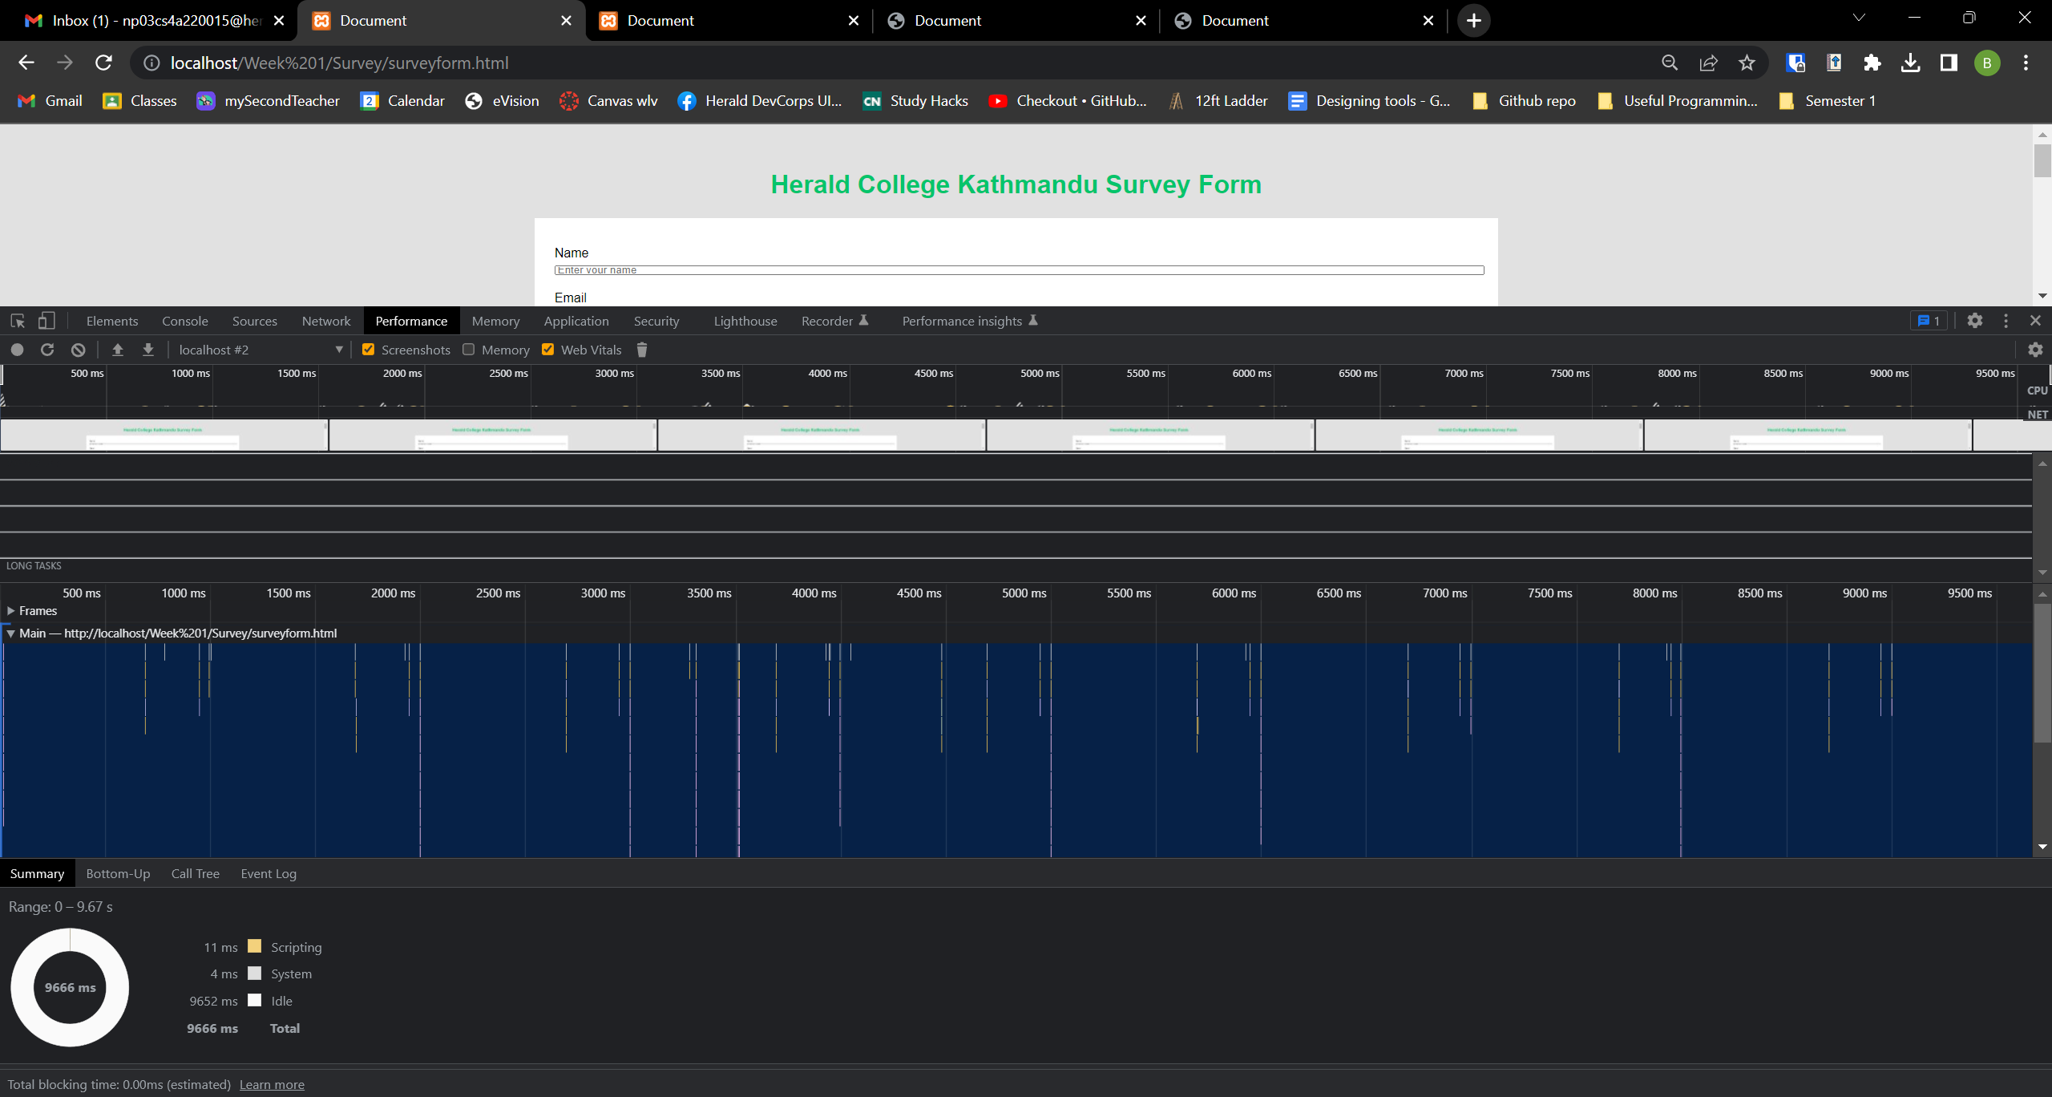

While recording the survey form website for about 10 sec (9.68 sec to be exact). The script was fully loaded in 11ms, and the system took 4ms. That means most of the time of the recording was website just staying idle and took 9666ms which translates to 9.652 seconds.

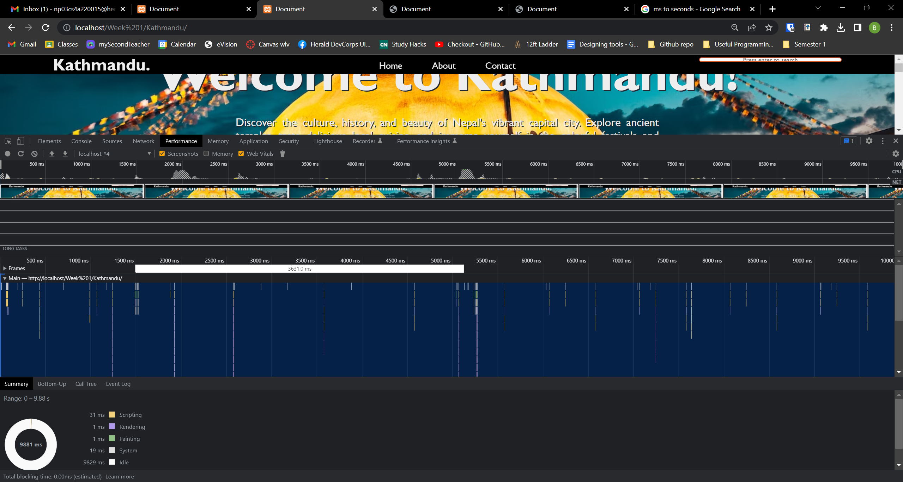

Whereas, in this website while recording almost the same time of 10 sec (9.88 seconds to be exact) the scripting took 31ms while to render and paint the page, it took both the task 1ms totaling to 2ms. The system for this website took 19ms to load. And for the rest of the duration of the recording, it mostly stayed idle taking 9829ms (9.829 seconds). Meaning the page fully loaded in less than a second to load.